BNM RMiT Compliance for Log360 Cloud
Automate BNM RMiT compliance and fortify cybersecurity resilience for financial institutions.
Region: Malaysia | Type: Financial Services, Incident Management | Category: Compliance | Pricing: Free

Overview
The BNM RMiT compliance extension in Log360 helps organizations meet the Bank Negara Malaysia Risk Management in Technology (RMiT) policy, which establishes technology risk management requirements for financial institutions regulated under FSA, IFSA, and DFIA by providing centralized log management, real-time SOC monitoring, and compliance-focused reporting. The platform supports BNM RMiT requirements for technology risk governance, access control with 3-year log retention, network security, cybersecurity operations, cloud services monitoring, data loss prevention, incident response, and third-party risk management.
For Technology Risk Governance and Board Oversight, Log360 provides comprehensive dashboards, risk metrics, and compliance reports that enable oversight of cybersecurity frameworks and technology risk management programs for senior leadership. To address Access Control and Identity Management, the platform monitors logon events, tracks privileged access, and flags anomalous access patterns across all platforms. The extension also supports Cybersecurity Operations and SOC Monitoring by providing capabilities that serves as the core SIEM for SOC operations, providing real-time log collection, event correlation, and skilled alert triage across all systems.

Key Features
- Network Security and Resilience: Log360 delivers real-time network monitoring, anomaly detection, and retains network device logs for compliance.
- Cyber Incident Response and Crisis Management: Log360 supports automated incident detection, classification, escalation workflows, and post-incident forensic analysis.
- Data Centre Resilience and Real-Time Monitoring: Log360 monitors infrastructure changes, backup activities, failover events, and system availability.
- Patch and Vulnerability Management: Log360 tracks patch deployment,
- correlates vulnerability scan results, and monitors unpatched critical systems.




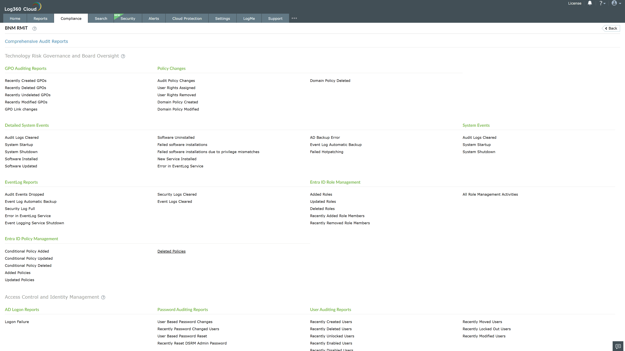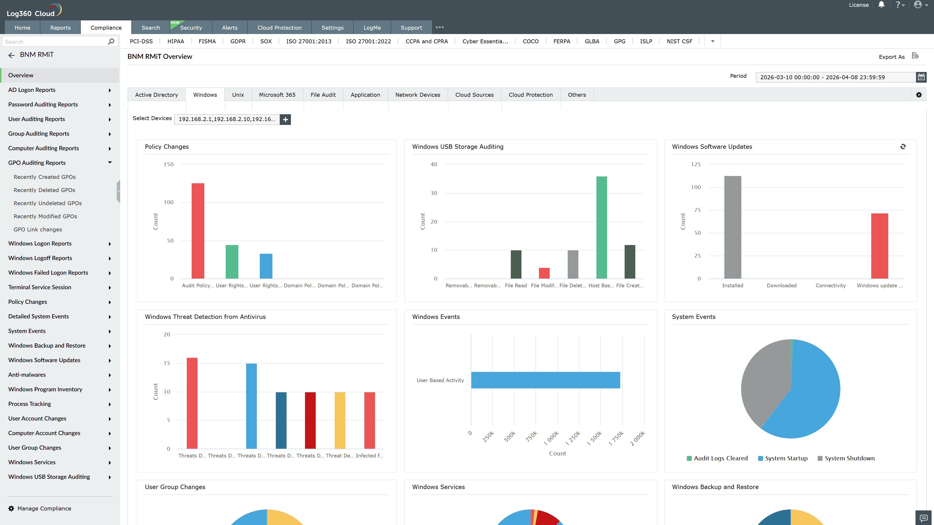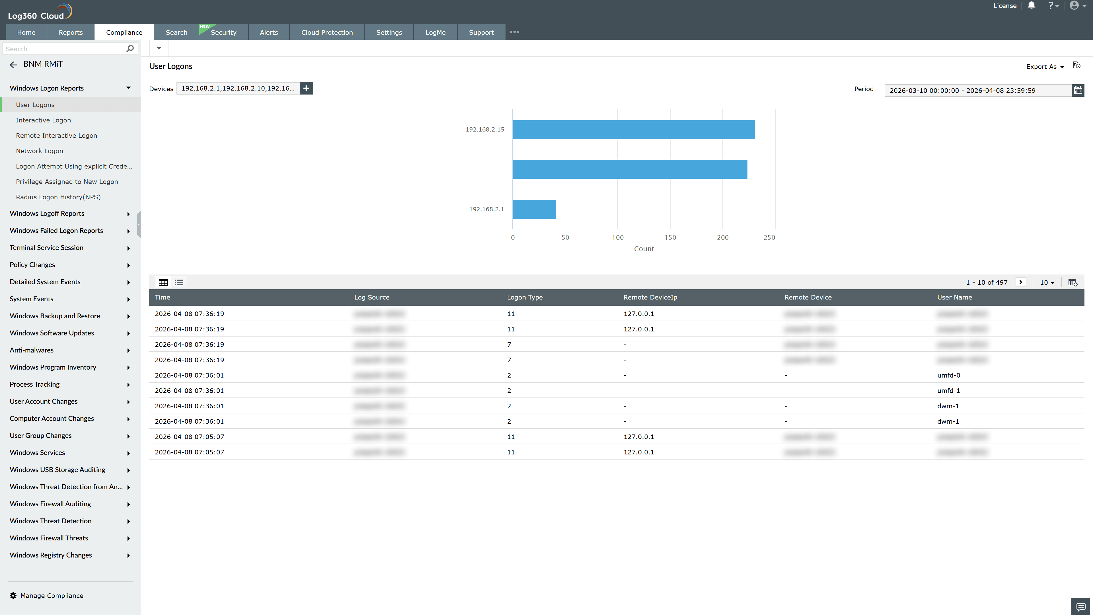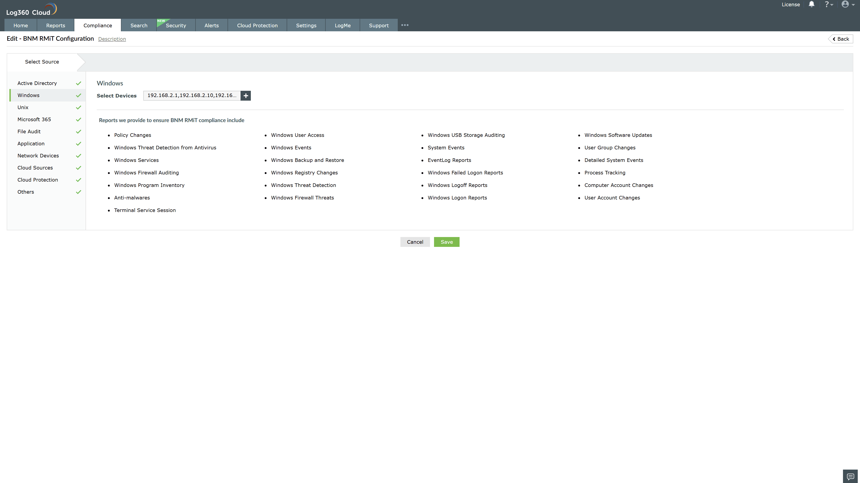
Valid Submission : Yes
Supported Editions : Free, Basic, Standard, Professional, MSSP
Help Document : https://www.manageengine.com/log-management/help/integrations/compliance-extensions.html
Help Video : Not provided
Tags : Log360, Compliance, Privacy monitoring, Data privacy, Regulatory compliance
Supported DCs : US, IN, JP, CA, AU, UK and EU
Privacy Policy:
Terms of Service:
Release Notes:
Predefined reports for the BNM RMiT.

